- Generate Password

Effect on increasing number of states
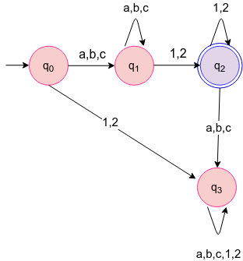
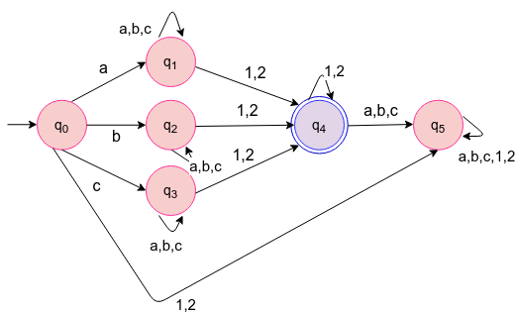
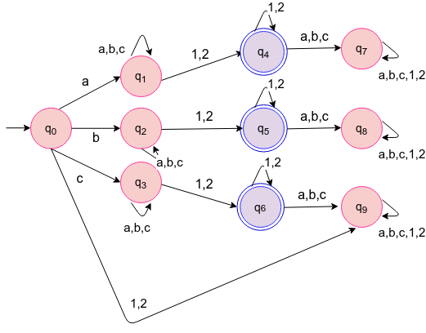

input sequence(100000)
buffer size=10
Number of states | Time taken by Ideal Enforcer | Time taken by Bounded Memory Enforcer | Number of times clean function is called
4 | 0.0924771547318 | 0.595969700813 | 99988
6 | 0.128909039497 | 0.727431249619 | 99988
10 | 0.189109373093 | 0.90841190815 | 99988

